Challenge Number: 1020
Played on date: April 8, 2023 Time: 14:00
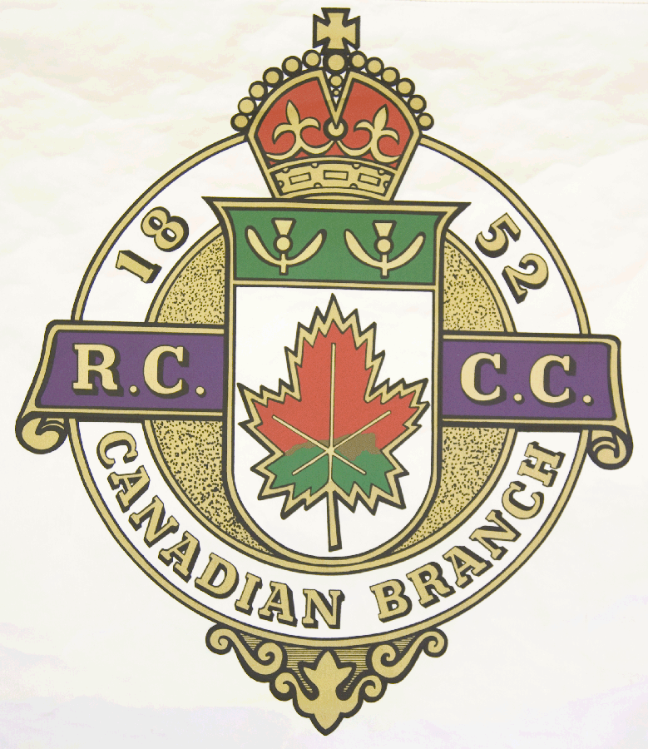
Hosting Club: North Hatley Curling Club

Host Club Address: 3245 Chemin Capelton

Host Club City: North Hatley, Qc.

Host Club Telephone: 819 - 842 - 2655

Host Contact Person: Marty Rourke

Contact phone or email: mrourke@ubishops.ca

Hosting Club: North Hatley Challenging Club: Royal Montreal

Skip: Marty Rourke Skip: Mark Billings

Third: Steve McPherson Third: Tim Lapin

Second: Joe Cox Second: Andy Tucker

Lead: Marc Cote Lead: Louis Bédard

Skip: Matt McCrea Skip: Andrew Wood

Third: Josh Bronson Third: Shawn Aumond

Second: Dan Camber Second: David Frost

Lead: John McCrea Lead: Carl Daviau .

 | Skip | 1 | 2 | 3 | 4 | 5 | 6 | 7 | 8 | 9 | 10 | Score
Sheet  1 | M. Rourke | 1 | 1 | 2 | 3 | 0 | 2 | 1 | 0 | X | X | 10
Sheet  1 | M. Billings | 0 | 0 | 0 | 0 | 2 | 0 | 0 | 1 | X | X | 3
Sheet  2 | M. McCrea | 3 | 1 | 1 | 0 | 2 | 3 | 0 | 2 | X | X | 12
Sheet  2 | A. Wood | 0 | 0 | 0 | 1 | 0 | 0 | 1 | 0 | X | X | 2

Hosting club score: 22____ Challenging club score: __ 5____

